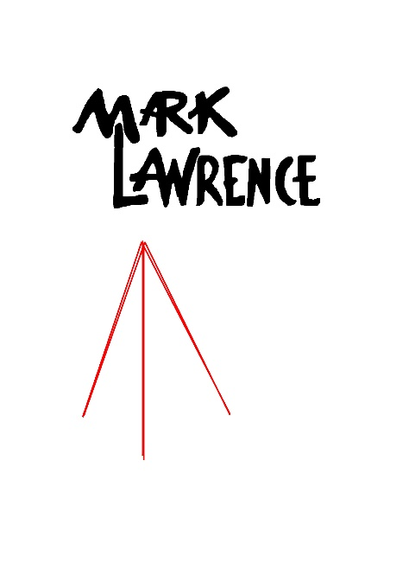

Attention all Bedford High Students and Parents:

Mark Lawrence Photographers will be at your school on

Friday 9/17/21 for Picture Day

Please follow the link below to preorder your portrait packages online.

There will also be a tradition paper ordering form going home to the students if you perfer to order that way. Please have your student return the form on Picture Day.

http://www.marklawrencephotographers.com/sytist/undergraduates-125/undergraduates/

Once you are on the page, please click on the camera icon to view the variety of packages Mark Lawrence has to offer. If you have any questions about ordering please call the
Nashua studio at 603.882.0116.

