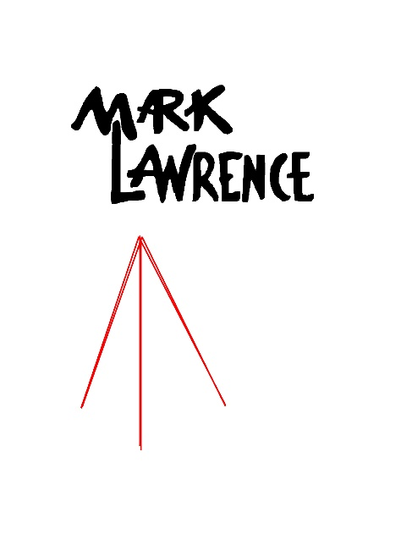

Attention all Bedford High Students and Parents:

Mark Lawrence Photographers will be at our school on the following days for school photos

Tuesday 1/12/21 Cohort B
Wednesday 1/13/21 Remote Students
Thursday 1/14/21 Cohort A

New this year Mark Lawrence will be offering an online ordering form.
Please follow the link below to order your portrait packages online.

http://www.marklawrencephotographers.com/sytist/undergraduates---all-other-schools/bedford-high/

Once you are on the page, please click on the camera icon to view the variety of packages Mark Lawrence has to offer. If you have any questions about ordering please call the
Nashua studio at 603.882.0116.

